Requel System Structure
This document describes the organization and structure of the Requel system for collaborative requirements acquisition. The Requel system is a JEE5 application (servlets only) intended to run in a web container such as Tomcat. The system runs on the Java 6 update 4 or later standard java runtime which includes JPA 1.0 (java persistence API) and JAXB 2.1 (java API for xml binding.)

System Components
The system utilizes many open source components for object configuration, transaction management, natural language processing, web interface, and persistence. It uses two home grown components that encapsulate and extend the natural language and web interface components.
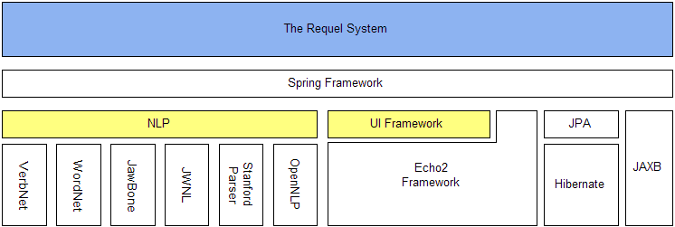
Figure 1: System Components

Spring Application Container
Spring is used as a dependency injection container to wire together the external and internal components of the system and for database/transaction management. The system uses a mix of annotation and file based component mapping that makes configuring the system both flexible and simple. Direct access to Spring’s container API is limited to only a few places: the main application servlet UIFrameworkServlet, the DatabaseInitializationListener, and in the command factories via the helper class ApplicationContextCommandFactoryStrategy.
There are multiple configuration files in /conf/spring/ that configure distinct aspects of the application.
jpaConfig.xml – This file defines the database configuration for use with the java persistence API. It uses the properties in conf/db.properties for the database specific settings and JPA implementation.
noDbConfig.xml – This file defines the configuration when no database is used. It tells Spring to use the repositories that hold data in memory.
uiFrameworkConfig.xml – This file tells Spring to scan all the classes in the uiframework package including built in screens, controllers, and the UIFrameworkApp class.
navigationConfig.xml – This file defines the configurations for Requel’s user interface objects, which get passed in to the UIFrameworkApp.
assistantConfig.xml – This file defines the components used by the automated assistants.
testConfig.xml – This file defines the database configuration used by the unit tests.

Java Persistence API and Hibernate
The Requel system uses the Hibernate JPA implementation.

NLP
The NLP component is a Façade that encapsulates a variety of natural language processing tools.
OpenNLP – is a collection of statistical natural language tools including a sentence detector, tokenizer, POS tagger, and constituent (phrase structure) parser.
Stanford Parser – is a statistical parser for both constituent and dependency parsing. It includes a tokenizer and POS tagger.
WordNet – is a lexical semantic database that associates words by meaning and various other relations.
VerbNet – is a collection of xml files containing sets of semantically related verbs with thematic roles and a set of frames describing how the verb relates to its arguments syntactically.
JWNL – is a java API for accessing the WordNet database.
Jawbone – is a java API for accessing the WordNet database. It includes filters for searching WordNet.

UI Framework
The UI Framework is an extension of the echo2 framework with facilities for screen and panel management, entity and event type navigation, and event based message passing via a message broker.
The framework is event based and uses a message broker (the EventDispatcher interface) to distribute messages between the user interface and controllers that handle data processing. By using a message broker the user interface is completely decoupled from the data processing. The real gain is in the connecting of message sources to message sinks. Listeners (both UI and data processing controllers) register the types of events and content they are concerned about with the message broker. When a message is dispatched the broker determines the recipients based on their concerns.
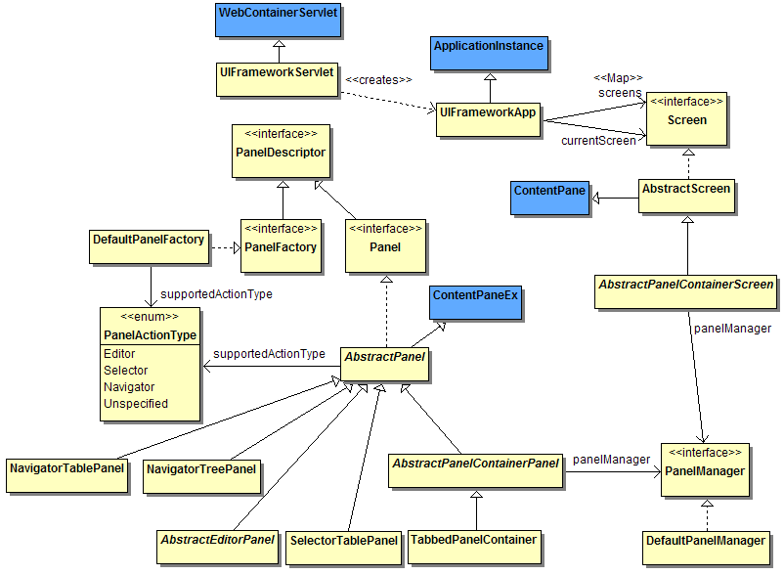
Figure 2: UIFramework Screen and Panels
The UI Framework uses Spring to wire together the event dispatcher, screens, panels and controllers with the UIFrameworkApp when a user first accesses the system through the UIFrameworkServlet.
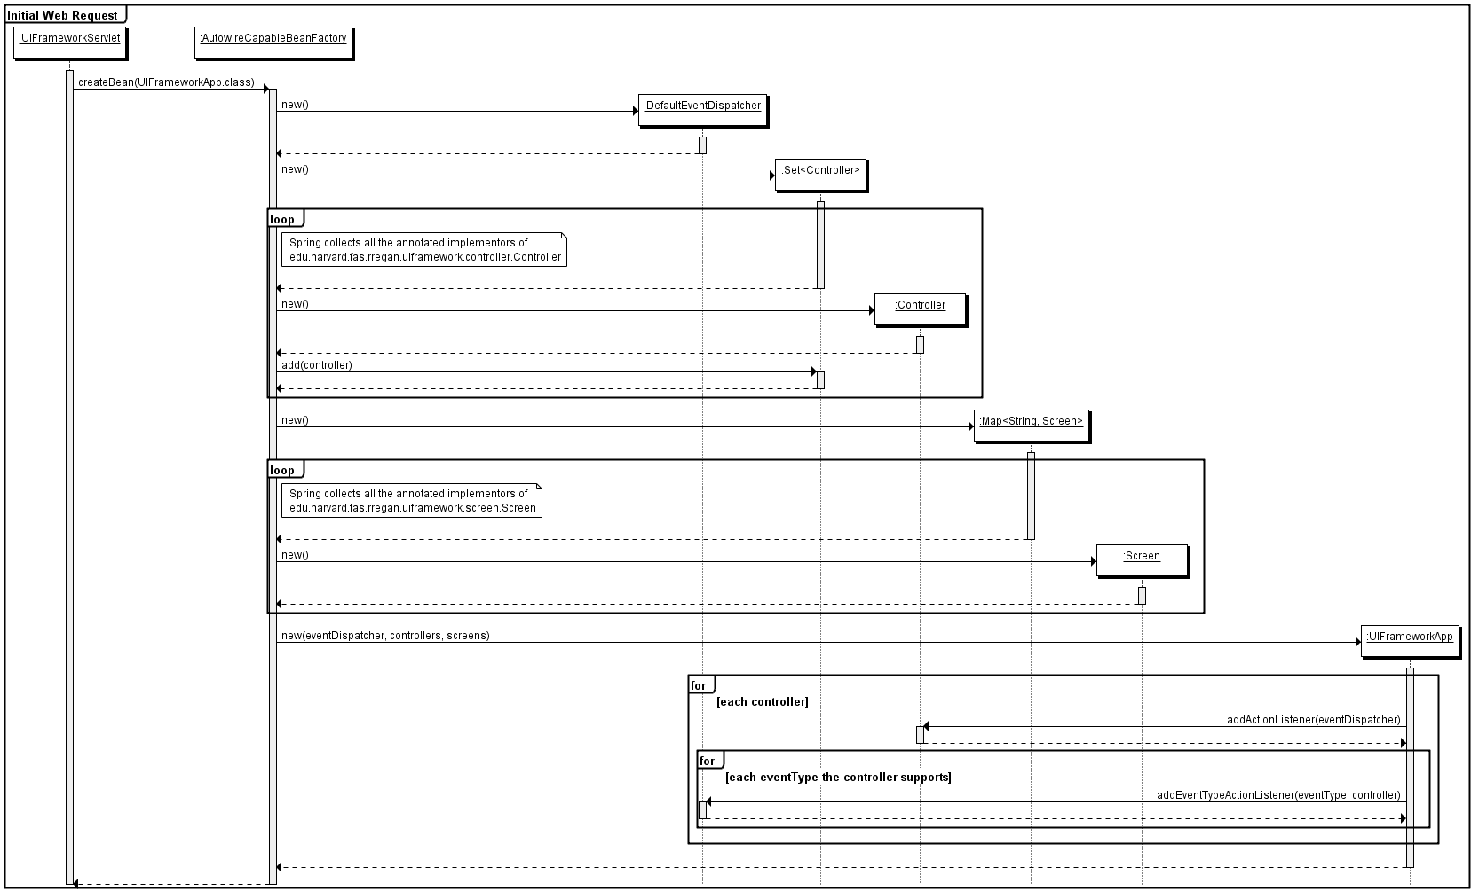
Figure 3: Initial Request Setup
The Echo2 Framework uses event based message passing to indicate simple user interface component actions such as clicking a button, selecting an item in a list, or changing the contents of a text box. The UI Framework builds on this mechanism with a richer set of event messages for navigational events such as login, logout, open a screen, open an edit panel for an entity, open a panel to search/select an entity of a particular type, or to indicate that an entity has been changed.
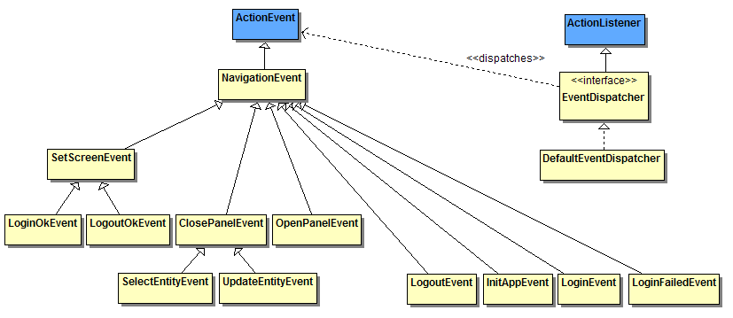
Figure 4: UI Framework Events
The framework uses two levels of event listeners. The first level listen for the component based events like button clicks. These listeners may be distinct classes such as the SubmitLoginListener or may be implemented directly by a panel. They are registered directly with the components that generate the events using methods such as addActionListener(). A first level listener may handle the event locally (within a single panel) by acting on the panel to change a data value on the panel or invoke a method on the panel, for example the save method on an editor panel. A first level listener may generate a higher level message like a LoginEvent and pass it through the EventDispatcher to a second level controller. The second level controller does some processing and may fire off a new event to the user interface or another controller for updating the user interface or further processing.

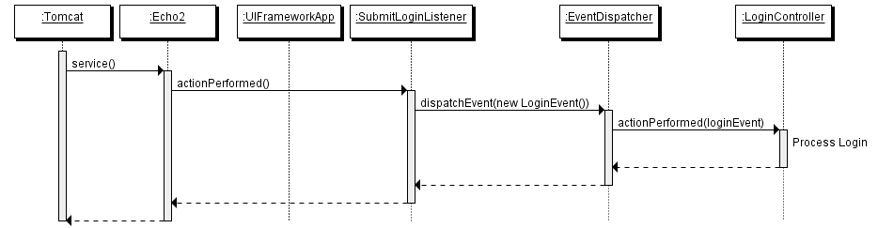
Figure 5: Login up to EventDispatcher
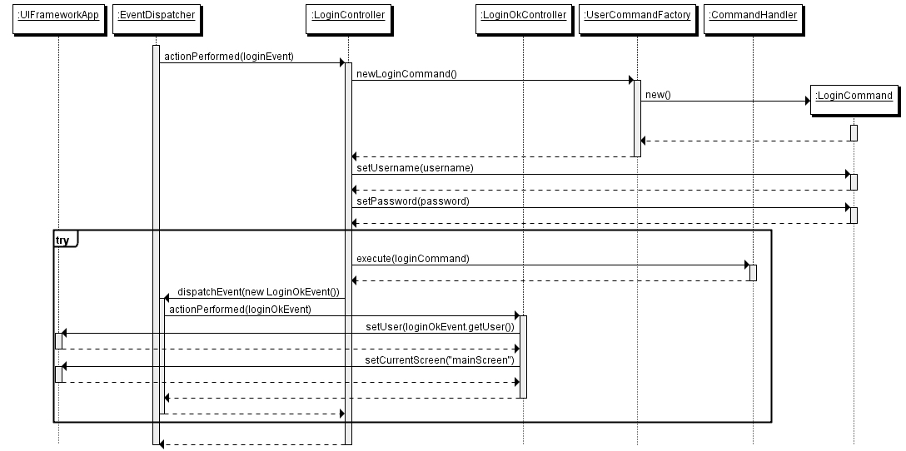
Figure 6: Login after EventDispatcher

Requel Sub Components
The Requel system is composed of several packages that distinguish different areas of concern.
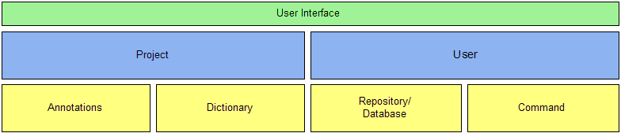
Figure 7: Requel Sub Components

User Interface
The user interface package builds on the UI Framework to create a rich web interface for the other components of the system.
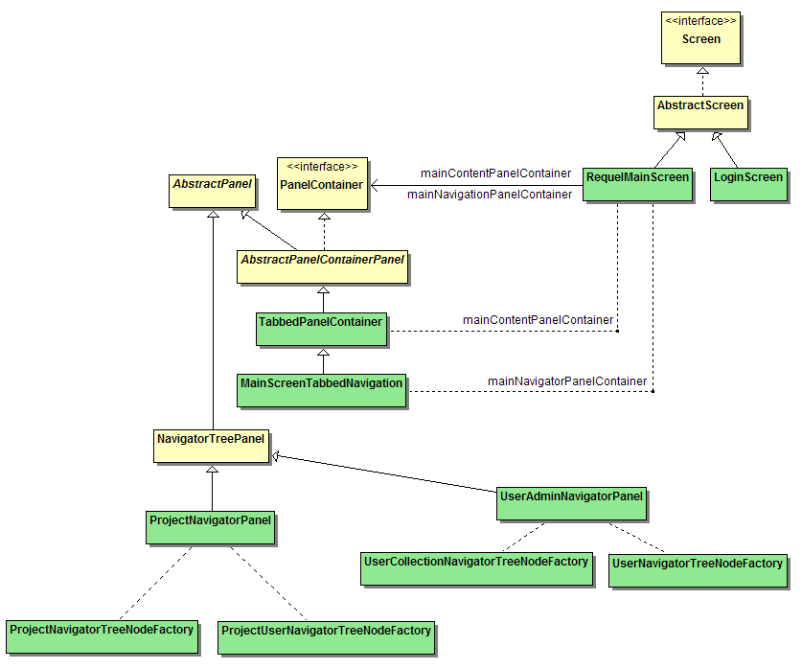
Figure 8: Requel Screens
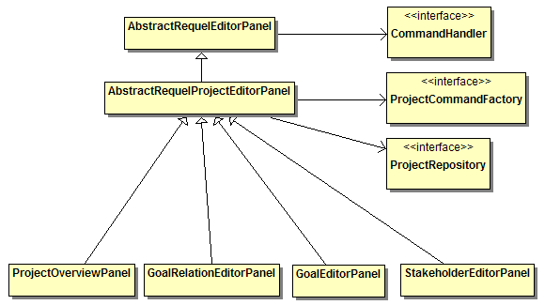
Figure 9: Project Entity Editor Panels

Project
The project package contains the public classes and interfaces concerned with requirements. It contains a sub package with the implementation including commands, database access, JAXB helper code, and the goal assistant.
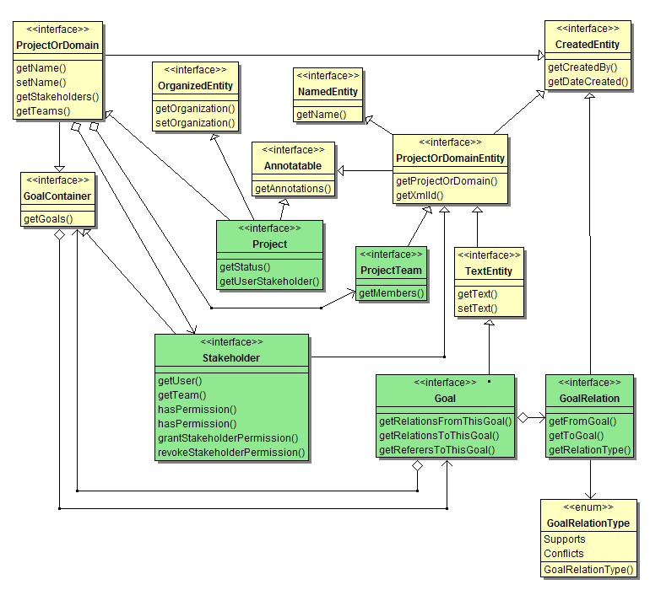
Figure 10: Project and Project Entities
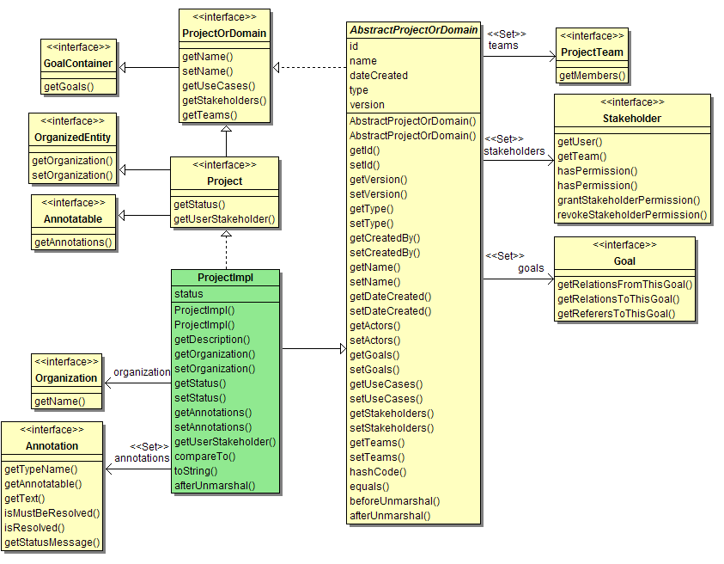
Figure 11: Project Implementation

User
The user package contains interfaces and classes related to users of the system and organizations used to group users into companies, work groups, or other organizational units. The UserRole and UserRolePermissions manage access to system level features, such as user administration or projects.
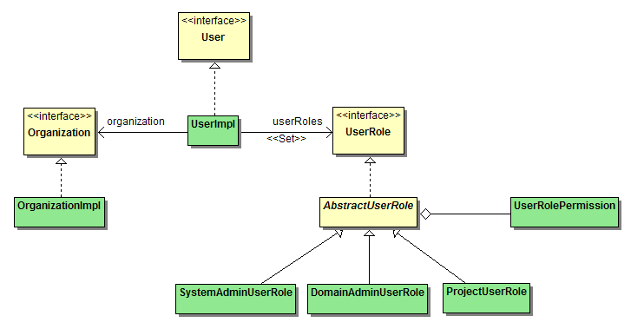
Figure 12: User and Roles

Annotations
The annotations package contains the features for adding notes and issues to project entities.
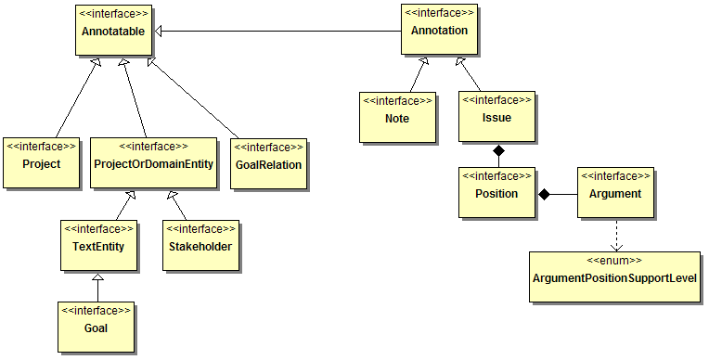
Figure 13: Annotations

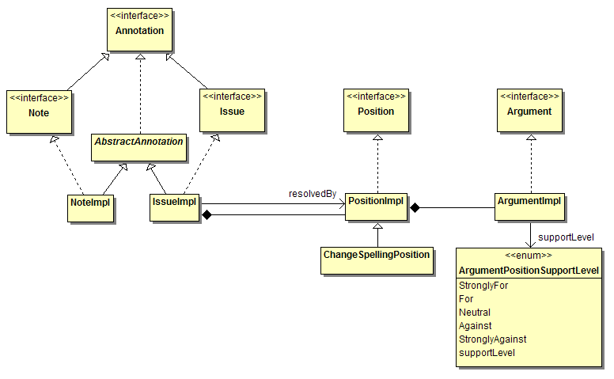
Figure 14: Annotation Implementation

Dictionary
The dictionary package is a utility package for access to the WordNet and VerbNet information stored in the database. This package will replace the NLP functionality to WordNet and allow editing of dictionary terms not available using the JWNL and JawBone components.
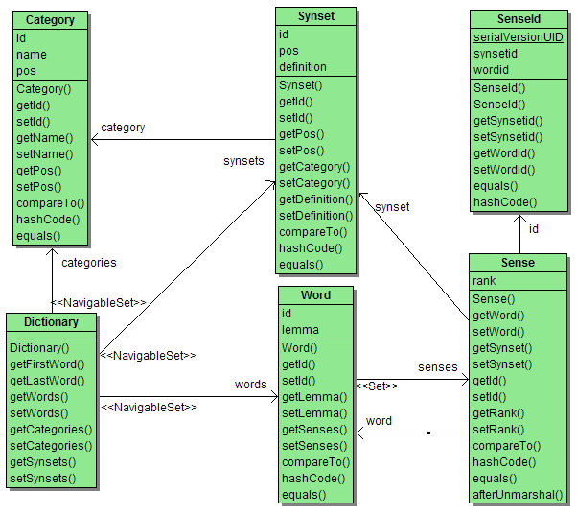
Figure 15: Dictionary

Repository/Database
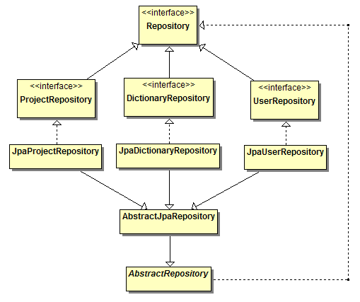
Figure 16: Repositories

Command
All the business logic in the Requel system is implemented in commands that are executed in a transactional context. The command package defines the abstract basis for all the commands in the system. Commands are managed by command factories where each package defines a factory for retrieving its specific commands.
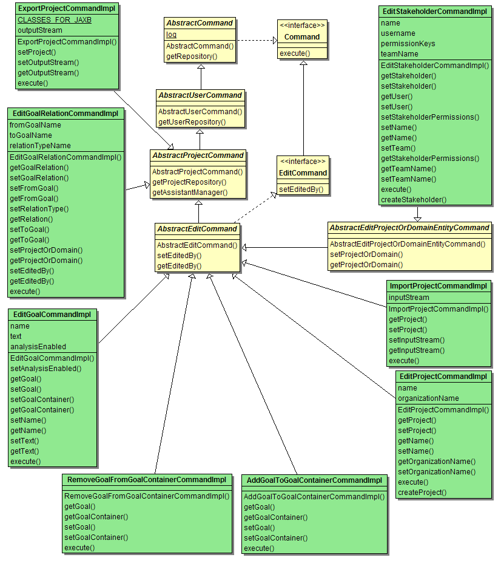
Figure 17: commands

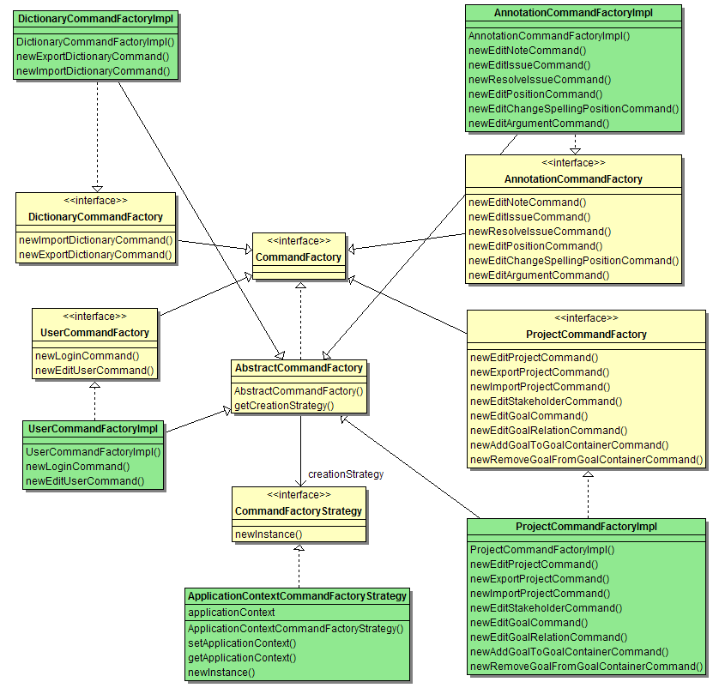
Figure 18: Command Factories

Application Initialization
The Requel system uses JEE ServletContextListeners to create the database, initialize Spring, and load data into the database when The servlet container starts. The listeners are declared in the web.xml file.
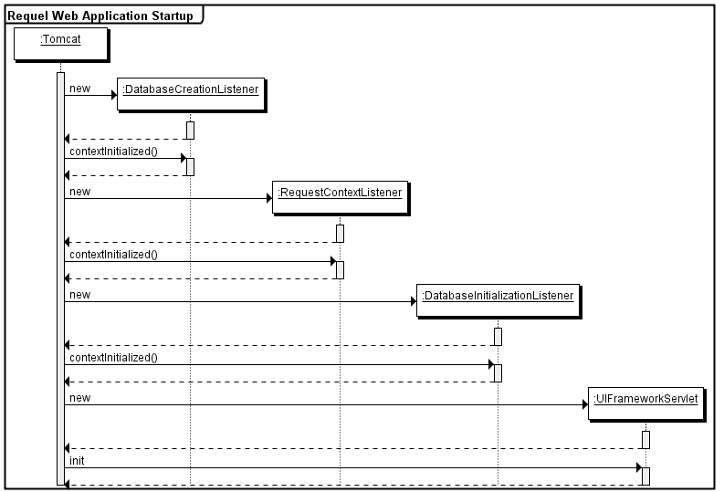
Figure 19: Initialization at Tomcat Startup
The DatabaseCreationListener attempts to connect to the expected database for the system, and if the connection fails because the database doesn’t exist, it creates the database.
The RequestContextListener is part of the Spring framework. It loads the spring configuration files and scans the classpath for classes annotated with Spring component annotations. Hibernate is initialized and the Schema Update automatically generates the database schema and creates the tables or updates them with changes to fields, constraints and indexes.
The DatabaseInitializationListener gets the DatabaseInitializer object from the Spring context. The DatabaseInitializer is configured with a Set of EntityInitializers declared via Spring annotations and identified via scanning. There are entity initializers for creating the default users, user and stakeholder permissions, and dictionary information.

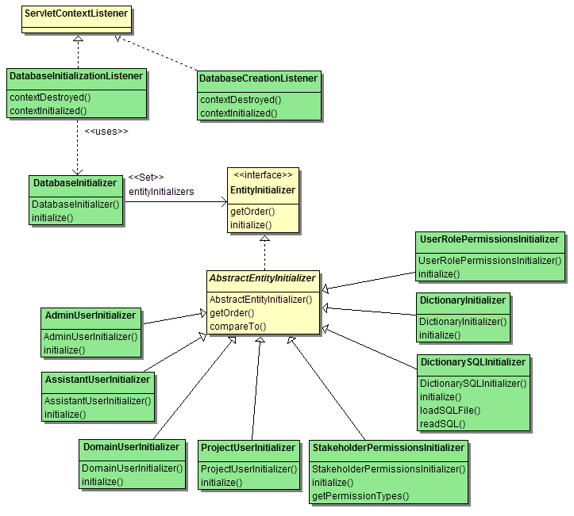
Figure 20: Database Initializers
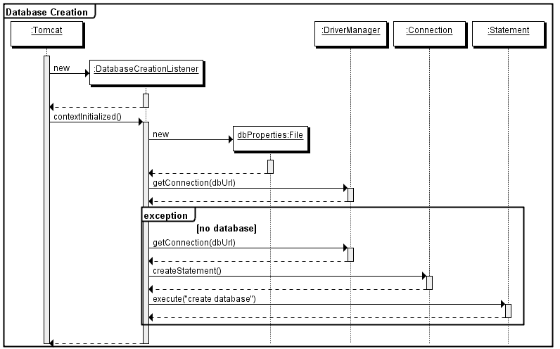
Figure 21: Database Creation Listener

